Contact:

Wahid Moorad
press@sigmasoft.de
+49-241-89495-1006
Kackertstr. 16-18
D-52072 Aachen

Press Release

SIGMASOFT® at K-2025
Simulation meets production reality

Numerous applications will be showcased at K 2025 in running injection molding production cells. Many of them were designed and optimized with SIGMASOFT® Virtual Molding.

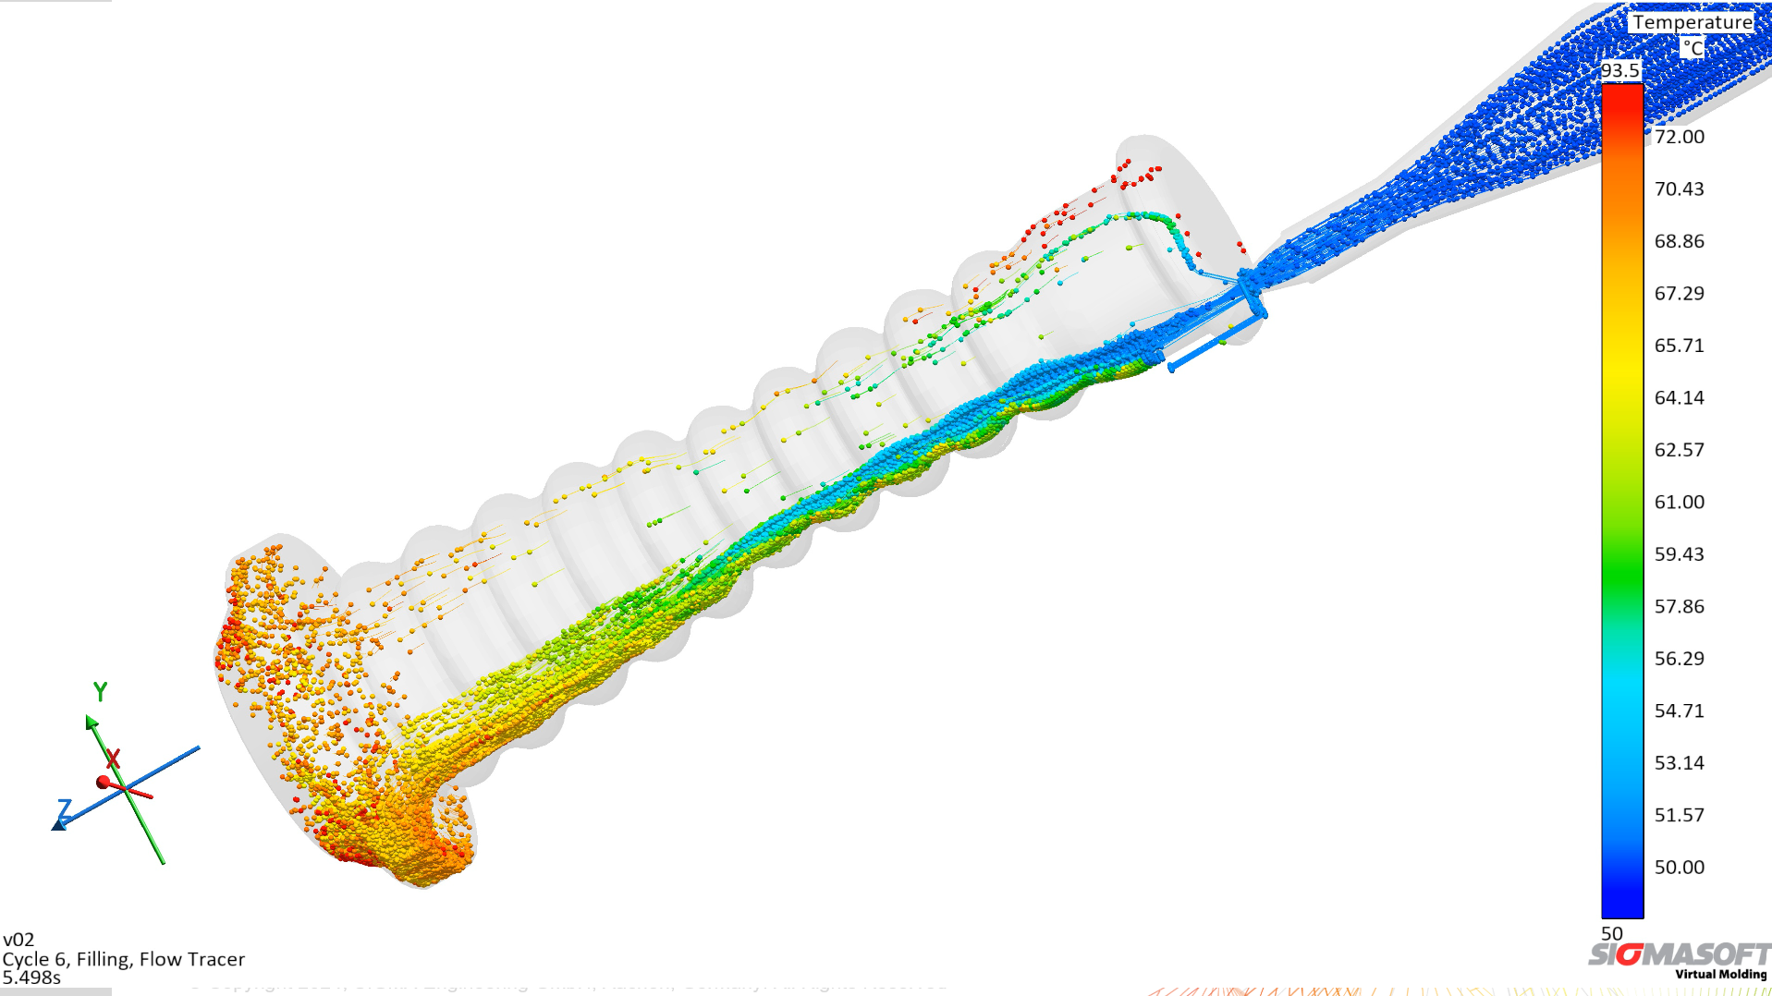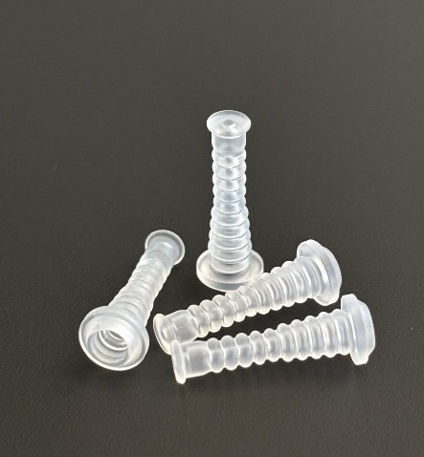
Needlfree Connector in Flow-Tracer View (Picture Reference: Nexus)

SIGMASOFT® at K 2025

Aachen, Oct 2nd, 2025 - At K 2025 in Düsseldorf (October 8–15), SIGMA Engineering GmbH will present the latest developments of SIGMASOFT® at booth A80 in Hall 13. In addition, numerous insights into ongoing part productions at K will be demonstrated and discussed.
In process simulation, the reliability of results is of crucial importance, as users now fully rely on digital reality. Time and additional costs for correction loops are no longer affordable in today’s highly competitive environment. At the SIGMA booth, visitors can learn about the details of various applications running at other exhibitors’ booths and gain a deeper understanding of what is really happening inside the tool during the process. Afterwards, they can compare the optimized simulation results directly with the reality of the running production cells.

Once again, this year, SIGMASOFT® was able to collaborate with several partner companies providing their data. At Momentive in hall 6, an exciting hard-soft combination will be produced: a frisbee. Maplan will demonstrate in hall 16 the production of a folding cup with lid using a four-cavity mold. Engel will showcase in hall 15 the complex manufacturing of a very large fuel cell seal, while Nexus will present the production of needle-free connectors at their new booth in hall 12. All these sophisticated production cells run fully automated with integrated robotics and will probably crowded. This offers a great opportunity to see further details at SIGMA, as the simulations make the tool steel transparent and allow deep insights into the inner workings of the mold.

SIGMASOFT® Virtual Molding has been continuously developed and improved for over 25 years, with the goal of representing reality ever more precisely. Continuous validation in practice is a decisive element of this process. “Normally, we can only demonstrate the comprehensive possibilities and advantages of SIGMASOFT® on screen,” says Timo Gebauer, CTO of SIGMA. “The K-show gives us the opportunity, together with our partners, to showcase how our results compare with reality. This allows professionals to clearly grasp the benefits and significance of process simulation for their own future applications.”
Since 1998, SIGMA Engineering GmbH has been driving the development of the injection molding process with its simulation solution SIGMASOFT® Virtual Molding. This virtual injection molding machine enables the optimization and development of polymer components and molds as well as the mapping of the entire production process. The SIGMASOFT® Virtual Molding technology combines the part’s 3D geometry with its tooling and temperature control system and integrates the parameters of the production process. This ensures a cost-efficient and resource-saving production as well as high-performance products - from the first shot.
SIGMASOFT® Virtual Molding integrates a multitude of process-specific models including 3D simulation technologies that have been developed and validated over decades and are being continuously optimized. The SIGMA Solution Service and Development team support customers’ specific goals with application solutions. The software company SIGMA offers application engineering, training, direct sales, and support. A software straight from its developers and designers to be a solution service to polymer engineering all over Europe.
SIGMA Engineering GmbH, headed by Managing Director Thomas Klein, has subsidiaries in the USA, Brazil, Singapore, China, India, Korea, and Turkey. In addition, SIGMA supports its users worldwide in a variety of international companies and research institutions with its Virtual Molding technology.
More information: sigmasoft.de

This press information is available to download in pdf and doc format under the following link: https://www.sigmasoft.de/en/press/

