Contact:

Katharina Aschhoff, M.Sc.
press@sigmasoft.de
+49-241-89495-1008
Kackertstr. 16-18
D-52072 Aachen

Press Release

Optimized Mold Tempering

Simulation Provides Insight and Reliable Improvement

At the Moulding Expo, SIGMA Engineering presents the simulation-based design of tempering systems using SIGMASOFT®. In collaboration with /H&B/ ELECTRONIC, conventional cooling is compared with conformal cooling. Additionally, optimized cooling channels made from metal 3D printing are presented, which can offer enormous advantages.

Aachen, May 8th 2023– At the Moulding Expo 2023 in Stuttgart (June 13-16, 2023), SIGMA Engineering GmbH presents at booth 1E18 insights into mold simulation and the simulative design of tempering systems using SIGMASOFT®. Simulation is critical to project success in plastics processing, including tooling, where geometries, gating position, and process design can already be optimized. /H&B/ ELECTRONIC relies on SIGMASOFT® for the design and dimensioning of temperature control channels.
Cooling is critical to the quality of thermoplastic components. Temperature differences lead to different cooling rates and create residual stresses and warpage in the finished component. This becomes problematic when there are differences in wall thickness within the component, as the cooling requirements are highly variable locally. Conformal cooling, meanwhile, is an established concept in tooling that is increasingly being used. Simulation allows the cost of conformal cooling to be evaluated in advance against the advantages of the conventional concept (improved component quality, shorter cycle times, etc.).
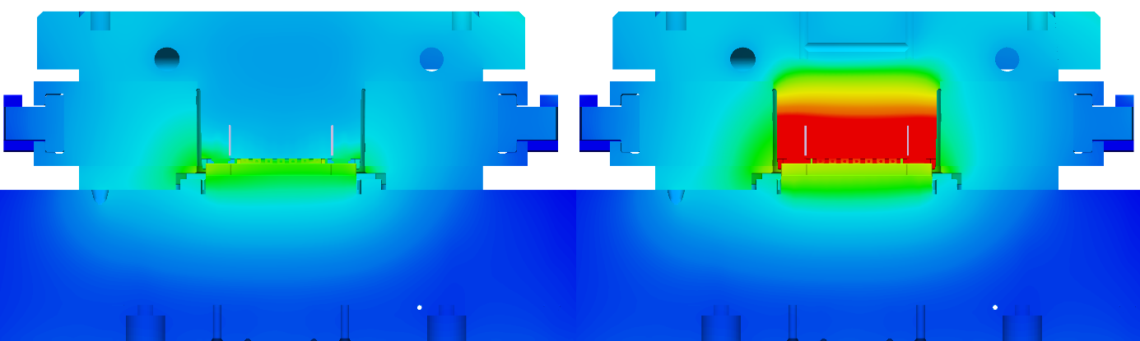
Image 1: Mold temperature control on the left using conformal cooling, on the right using conventional cooling

3D printing has revolutionized the possibilities for component production. It is now possible to produce completely arbitrary channels (regardless of feasibility using milling, drilling, assembly, and sealing). /H&B/ ELECTRONIC and SIGMASOFT® have carefully examined the simulation-based design of a novel temperature control system made using 3D printing. The results will be shown at both exhibitors' stands at the trade fair.
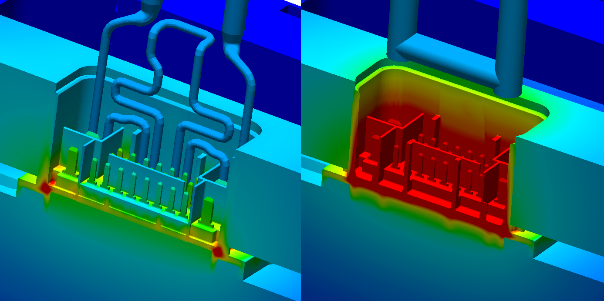
Image 2: Temperature distribution just before demolding, with conformal cooling from 3D printing on the left (only visible halfway trough), and conventional cooling on the right.

"Analysis and fluidic design of cooling channels are just one of dozens of successful applications of SIGMASOFT®," explains Timo Gebauer, CTO of SIGMA. "What they all have in common is the ability to understand what is happening before money and time are invested. This was an exciting project where we were able to accompany this successful innovation." Jan Bayerbach, Head of Development & Construction at /H&B/ ELECTRONIC, adds: "We have been relying on SIGMASOFT® for many years to develop and optimize our products before they are even manufactured. The good correlation between simulation and reality has always impressed us. We are particularly proud of the mold inserts we developed using 3D printing."

Since 1998, SIGMA Engineering GmbH has been driving the development of the injection molding process with its simulation solution SIGMASOFT® Virtual Molding. This virtual injection molding machine enables the optimization and development of polymer components and molds as well as the mapping of the entire production process. The SIGMASOFT® Virtual Molding technology combines the parts 3D geometries with its tooling and temperature control system and integrates the parameters of the production process. This ensures a cost-efficient and resource-saving production as well as high-performance products - from the first shot.
SIGMASOFT® Virtual Molding integrates a multitude of process-specific models including 3D simulation technologies that have been developed and validated over decades and are being continuously optimized. The SIGMA Solution Service and Development team support customers specific goals with application solutions. The software company SIGMA offers application engineering, training, direct sales and support. A software straight from its developers and designers to be a solution service to polymer engineering all over Europe.
SIGMA Engineering GmbH, headed by Managing Director Thomas Klein, has subsidiaries in the USA, Brazil, Singapore, China, India, Korea and Turkey. In addition, SIGMA supports its users worldwide in a variety of international companies and research institutions with its Virtual Molding technology.
More information: sigmasoft.de

This press information is available to download as pdf and doc format under the following link: https://www.sigmasoft.de/en/press/

