Contact:

Katharina Aschhoff, M.Sc.
press@sigmasoft.de
+49-241-89495-1008
Kackertstr. 16-18
D-52072 Aachen

Press release

SIGMA Technical Talks
Second set of the successful webinar-series

Based on the good feedback to last year’s SIGMA Technical Talks this webinar series will be offered again with new partners, topics, and presentations over several weeks this spring.

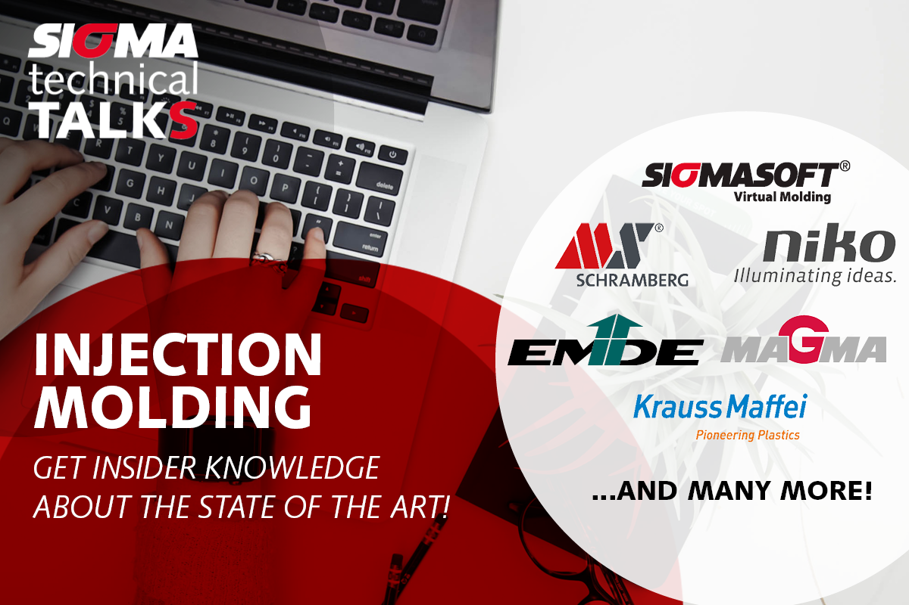
Figure 1 – Banner

Aachen, 16.02.2022 – SIGMA Engineering in cooperation with numerous experts from industry partners organizes webinars starting in March 2022. These around 90 minutes web meetings will showcase three presentations from different companies. The individual topics are as versatile as the application areas of SIGMASOFT®. The events will focus on injection molding of thermoplastics, elastomers, and LSR, as well as compression molding of elastomers. The webinars will be held in different languages, besides English, there are talks announced in German, French, and also Spanish.
„Like everybody else we had to learn to run virtual meetings efficiently. The good feedback we got from our previous events was encouraging us to improve and run this successful series of webinars again with fresh content“, says Timo Gebauer, CTO of SIGMA. „We are happy to get again excellent support through our users and industry partners. In times where having personal meetings continues to be difficult, such joint events are efficient forums for exchange about technology and innovation.“
The webinars take place on Wednesdays at 10:00 a.m. Participation is free for all interested delegates and only requires registration in advance on www.sigmasoft.de in the Academy Calendar.

Since 1998 SIGMA Engineering GmbH has been driving the development of the injection molding process with its simulation solution SIGMASOFT® Virtual Molding. This virtual injection molding machine enables the optimization and development of plastic components and molds as well as the mapping of the entire production process. The SIGMASOFT® Virtual Molding technology combines the parts 3D geometries with its tooling and temperature control system and integrates the parameters of the production process. This ensures a cost-efficient and resource-saving production as well as high-performance products - from the first shot.

SIGMASOFT® Virtual Molding integrates a multitude of process-specific models including 3D simulation technologies that have been developed and validated over decades and are continuously optimized. The SIGMA Solution Service and Development team supports its customers technical goals with application-specific solutions. The software company SIGMA offers application engineering, training, direct software sales and as a result, a software straight from its developers and designers to help give a solution service by engineers all over Europe.

SIGMA Engineering GmbH, headed by Managing Director Thomas Klein, has subsidiaries in the USA, Brazil, Singapore, China, India, Korea and Turkey. In addition, SIGMA supports its users worldwide in a variety of international companies and research institutions with its Virtual Molding technology.
Further information: sigmasoft.de

This press information is available to download as pdf and doc format under the following link: https://www.sigmasoft.de/en/press/

