Contact:

Katharina Aschhoff, M.Sc.
press@sigmasoft.de
+49-241-89495-1008
Kackertstr. 16-18
D-52072 Aachen

Press Release

SIGMASOFT® shows the virtual processing of Silicones

Optimizing an LSR molding process before mold making

During the first Silicone Expo Europe in Amsterdam, SIGMA Engineering presents the new version 6.0 of SIGMASOFT® Virtual Molding. The completely redesigned user interface is easier to use and allows beginners and experts to efficiently handle the extensive process-simulations suite. In LSR molding, the system is used more often than any alternative product and saves time and money for leading mold makers and processors daily.

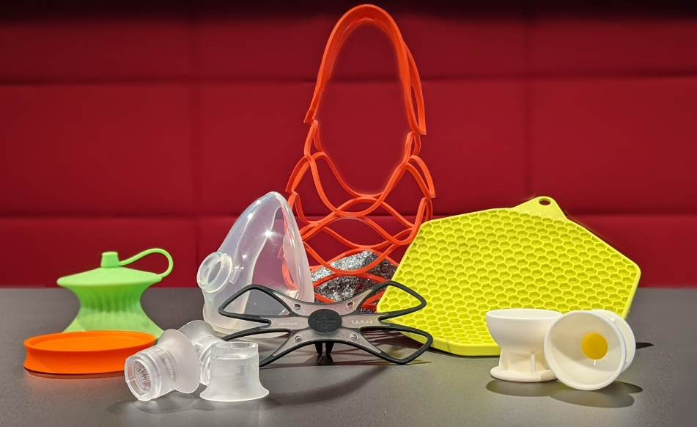
Picture: Numerous projects prove the conformity of simulation and reality

SIGMASOFT® and Silicone – Both start with Si like Silicon
Aachen, 16.01.2023 – On Silicone Expo 2023 in Amsterdam (March 21st-23rd) SIGMA Engineering GmbH presents the evolution of SIGMASOFT® at booth 535. The new version 6.0 has a completely new user interface and now includes, among other new features, the analysis of traditional compression molding.
25 years after the company was founded, SIGMASOFT® is well adopted by leading Silicone processors and mold makers globally. Shortened lead times, risk assessments and sustainability are important arguments to optimize new developments by simulation and avoid mistakes before they happen. In fully automated LSR molding, seconds in cycle time can impact economics while failures (if at all) are only accepted in ppm range. SIGMA supports its customers and project partners with continuously optimized Virtual Molding technology to keep up or outperform this industry standard.
In past years, the surprisingly precise conformity between simulation and reality was regularly shown in public on running machines on tradeshows like Fakuma, K, or DKT. The picture shows such parts from projects in one shot as well as multi-component molding with LSR and HCR. Without a working industry network of leading mold makers, equipment- and raw material suppliers this wouldn’t have happened. The majority of the involved partners also use SIGMASOFT® successfully in their own companies. With the support of the raw material suppliers, a broad silicone material database was built over the years. It makes predictions even more precise and allows swift virtual material changes
At the booth of SIGMA, visitors can learn about SIGMASOFT® and its solutions for silicone elastomers. They get first-hand information, on how detailed many specific questions can be answered quickly with help of this software. „We are excited to be part of the first Silicone Expo in Europe“, says Thomas Klein, managing director of SIGMA. „For us, it was an easy decision to be here physically. Many of our existing customers are even here as exhibitors. We look forward to meeting many known faces but also new expert contacts from the world of silicones.“

Since 1998, SIGMA Engineering GmbH has been driving the development of the injection molding process with its simulation solution SIGMASOFT® Virtual Molding. This virtual injection molding machine enables the optimization and development of polymer components and molds as well as the mapping of the entire production process. The SIGMASOFT® Virtual Molding technology combines the part’s 3D geometry with its tooling and temperature control system and integrates the parameters of the production process. This ensures a cost-efficient and resource-saving production as well as high-performance products - from the first shot.
SIGMASOFT® Virtual Molding integrates a multitude of process-specific models including 3D simulation technologies that have been developed and validated over decades and are being continuously optimized. The SIGMA Solution Service and Development team support customers’ specific goals with application solutions. The software company SIGMA offers application engineering, training, direct sales, and support. A software straight from its developers and designers to be a solution service to polymer engineering all over Europe.
SIGMA Engineering GmbH, headed by Managing Director Thomas Klein, has subsidiaries in the USA, Brazil, Singapore, China, India, Korea, and Turkey. In addition, SIGMA supports its users worldwide in a variety of international companies and research institutions with its Virtual Molding technology.
More information: sigmasoft.de

This press information is available to download in pdf and doc format under the following link: https://www.sigmasoft.de/en/press/

