Contact:

Katharina Aschhoff, M.Sc.
press@sigmasoft.de
+49-241-89495-1008
Kackertstr. 16-18
D-52072 Aachen

Press release

Compression Molding is completely transparent

A detailed view into the mold

On K 2022, SIGMA Engineering presents the new version 6.0 of SIGMASOFT® Virtual Molding. Besides the reworked intuitive user interface one highlight is the introduction of simulative Compression Molding. It allows to zoom into the production process in every location, anytime and in any cycle. Examples include the thermal influence of the open mold, during preparation and while preforms are positioned – or to analyze plastification and curing of the elastomer in detail.

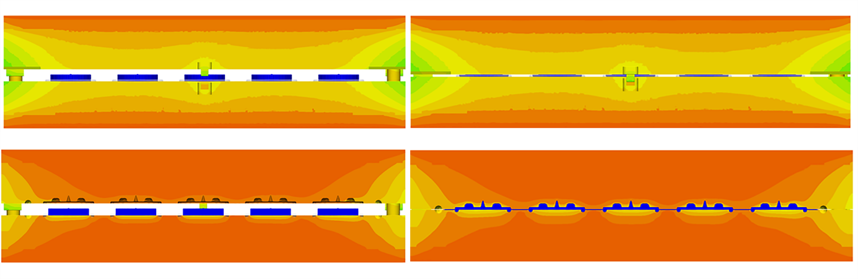
Bild 1 – The view of the mold when opening: left, when closing: right. Thermal influences in the mold seen from the outside: above, from the center: below.

Compression Molding is completely transparent

Aachen, 25.08.2022 – On K 2022 in Duesseldorf (October 19-26th 2022) SIGMA Engineering GmbH presents the evolution of SIGMASOFT® at booth 13-B29. The new version 6.0 has a completely fresh user interface and beside other new features now also contains the possibility to analyze the traditional Compression Molding of elastomers.
Until now, simulative mold and process design were limited mainly to modern injection molding technology. SIGMASOFT® has already been utilized successfully by leading elastomers processors, and their desire to also simulate the older processes was voiced many times. The industrial significance of Compression and Transfer Molding remains high, as safety and precision parts are also manufactured using these processes. The use of high-quality materials makes a better process understanding and in advance optimization through simulation even more desirable. The simulation also allows for a secure evaluation of curing degree and process-cycle data. Issues such as the quantity, shape, weight, and position of the preforms can also be optimized easily. This allows to improve the quality of the molded parts while reducing the material usage - without cumbersome and costly series of trials. In SIGMASOFT®, all thermal influences on the component and in the mold, from the smallest screw to the energy loss of the mold over several cycles, can be viewed in detail during the simulation of compression molding. This makes thermal optimizations or improvements on cycle time easy.
“It sounds easy, but implementation was quite complex”, explains SIGMA CTO Timo Gebauer: “The challenge is, that the cavity, or the room where we otherwise inject into, constantly changes during the closing of the mold. At the same time, the inserted preforms are already heating up, and are plasticizing and deforming. This development would not have passed the finish line without continuous advice and validation through our customers.”

Since 1998, SIGMA Engineering GmbH has been driving the development of the injection molding process with its simulation solution SIGMASOFT® Virtual Molding. This virtual injection molding machine enables the optimization and development of polymer components and molds as well as the mapping of the entire production process. The SIGMASOFT® Virtual Molding technology combines the parts 3D geometries with its tooling and temperature control system and integrates the parameters of the production process. This ensures a cost-efficient and resource-saving production as well as high-performance products - from the first shot.
SIGMASOFT® Virtual Molding integrates a multitude of process-specific models including 3D simulation technologies that have been developed and validated over decades and are being continuously optimized. The SIGMA Solution Service and Development team support customers specific goals with application solutions. The software company SIGMA offers application engineering, training, direct sales and support. A software straight from its developers and designers to be a solution service to polymer engineering all over Europe.
SIGMA Engineering GmbH, headed by Managing Director Thomas Klein, has subsidiaries in the USA, Brazil, Singapore, China, India, Korea and Turkey. In addition, SIGMA supports its users worldwide in a variety of international companies and research institutions with its Virtual Molding technology.
More information: sigmasoft.de

This press information is available to download as pdf and doc format under the following link: https://www.sigmasoft.de/en/press/

